A company keeps the following table of data about orders.

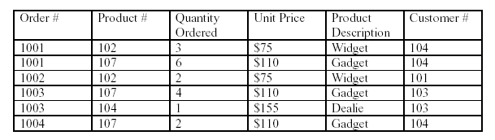

Which normal forms are violated?

Anomalies?